PROJECT DOCUMENTATION
SCRIPT-CONTROLLED ACL
Restrict Record Access Based on Field Value
ServiceNow Micro Project

TEAM MEMBERS
DEVI ISWARIYA S (TEAM LEADER)
DEVI SHREE A
DHANYASRI S
DHARANI S

1. Project Overview
This project demonstrates the implementation of script-controlled Access Control Lists (ACLs) in ServiceNow to enforce record-level security on a custom table named u_institution_details. The main scenario is to restrict visibility of records according to the Branch field. The supplied lab document specifies that users with the bb1 role can view EEE branch records, while administrators retain full access. Additional Create, Write, and Delete ACLs are then used to control other operations through the bb2, bb3, and bb4 roles respectively.

The project combines user/role configuration, custom table creation, record creation, ACL configuration, scripting, impersonation-based testing, and verification of the final access behavior.

2. Problem Statement

A ServiceNow application may contain institution and student information that should not be available to every user. A simple role check may not be sufficient when access must also depend on a value stored in the record. This project addresses that requirement by using ACLs and a script/data condition so that access decisions are controlled at the record level.

3. Objectives

- Create a test user and custom roles required for ACL testing.
- Create the custom Institution Details table named u_institution_details.
- Add student, faculty, branch, contact, and description fields to the table.
- Create sample records with different branch values such as ECE, EEE, and CSE.
- Configure a READ ACL using the bb1 role and the Branch = EEE condition.
- Configure CREATE, WRITE, and DELETE ACLs using bb2, bb3, and bb4 respectively.
- Use impersonation to verify access behavior for different users.
- Demonstrate how ACLs control viewing, creation, editing, and deletion of records.

4. Scope of the Project

The project is limited to record-level security for the custom u_institution_details table. It covers READ, CREATE, WRITE, and DELETE operations. The supplied lab also describes the use of the admin role for full access and the use of the bb1–bb4 custom roles for controlled access.

5. Technologies and Platform

- Platform: ServiceNow
- Security mechanism: Access Control Lists (ACLs)
- ACL type: Record
- Custom table: u_institution_details
- Testing method: User impersonation and list/form verification
- Scripting: ServiceNow server-side ACL script using gs.hasRole()

6. User and Role Creation

The first milestone is to create a test user and the custom roles required by the ACLs. The lab specifies a test user named EEE User with the email eeeuser@gmail.com. Four custom roles—bb1, bb2, bb3, and bb4—are created and assigned to the test user.
- Navigate to User Administration → Users and click New.
- Create the user with User ID: EEE User.
- Set First name as EEE and Last name as User.
- Set the email as eeeuser@gmail.com and save.
- Navigate to User Administration → Roles.
- Create bb1, bb2, bb3, and bb4.
- Assign the required roles to the test user.

7. Custom Table Creation

A custom table called Institution Details is created under System Definition → Tables. The table name is u_institution_details and it is not configured to extend another table.
- Label: Institution Details
- Name: u_institution_details
- Extends for: false
- Student Roll Number – Auto Number
- Student Name – Reference to User
- Faculty Name – Reference to User
- Branch – Choice (ECE, EEE, CSE)
- Email – String
- Phone Number – String
- Description – Multi String
After the table and fields are saved, multiple records are created using different branch values. This variation is important because the READ security scenario depends on the Branch field.

8. Access Control List Configuration

ACLs are configured from System Security → Access Control (ACL). The lab requires the security_admin role to be elevated before creating the ACL records. Each ACL is configured as a record ACL for the u_institution_details table.
Operation | ACL Name | Required Role | Condition | Purpose
Read | u_institution_details | bb1 | Branch = EEE | Control which records can be viewed
Create | u_institution_details | bb2 | No data condition | Allow record creation
Write | u_institution_details | bb3 | No data condition | Allow record modification
Delete | u_institution_details | bb4 | No data condition | Allow record deletion

9. READ ACL – Script-Controlled Access

The READ ACL is the central part of the project. It is created with Type = record, Operation = read, Name = u_institution_details, and Active = true. The Advanced option is enabled. The Requires role list contains bb1, and the data condition is configured as Branch is EEE.
The supplied lab uses the following ACL script:
(function () {
// Allow admin users full access
if (gs.hasRole('admin')) {
return true;
}
// Allow only EEE branch users to see EEE records
if (gs.hasRole('bb1')){
return true;
}
// Deny access for all others
return false;
})();
In the supplied configuration, the branch restriction is represented by the ACL Data Condition (Branch is EEE), while the script checks the user's role. The script explicitly grants access to administrators and to users having bb1; otherwise it returns false. This distinction is important when explaining the implementation: the Branch = EEE restriction is configured as the data condition, not as a comparison inside the shown script.
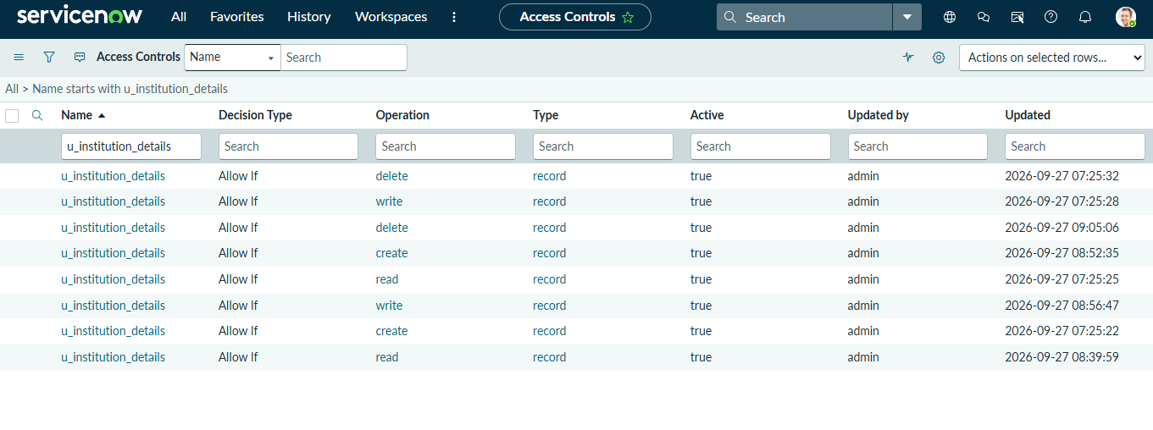
Figure 1. Access Control list showing ACL records for u_institution_details.
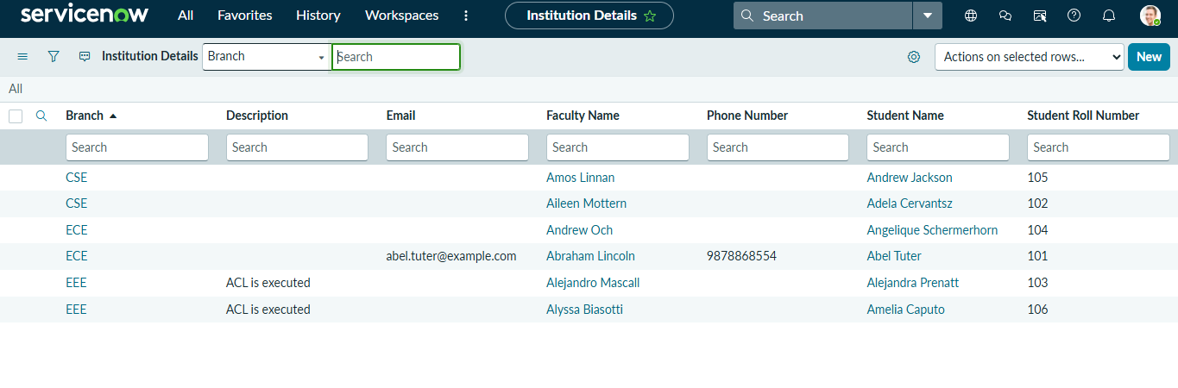
Figure 2. Institution Details list showing records with different branch values.

10. READ ACL Verification

The lab instructs the administrator to impersonate the EEE user and open the Student Records list. The table list can be opened using u_institution_details.list. The administrator is also impersonated to verify unrestricted access.
- A user with the bb1 role is expected to view EEE branch records according to the lab configuration.
- A user without the required role is expected not to view the protected records.
- An administrator is expected to have access to all records.

11. CREATE ACL

The CREATE ACL controls whether a user can create a new record in the u_institution_details table. The ACL is created as a record ACL with Operation = create and Active = true. The required role is bb2. The supplied lab specifies no additional data condition for this ACL.
- Type: record
- Operation: create
- Name: u_institution_details
- Active: true
- Required role: bb2
- Data condition: none
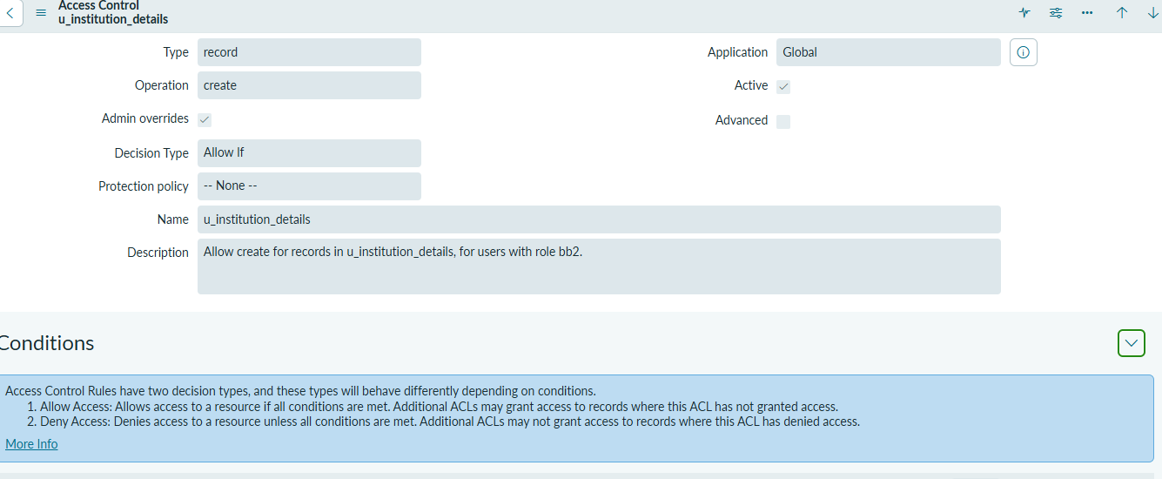
Figure 3. CREATE ACL configuration for u_institution_details.
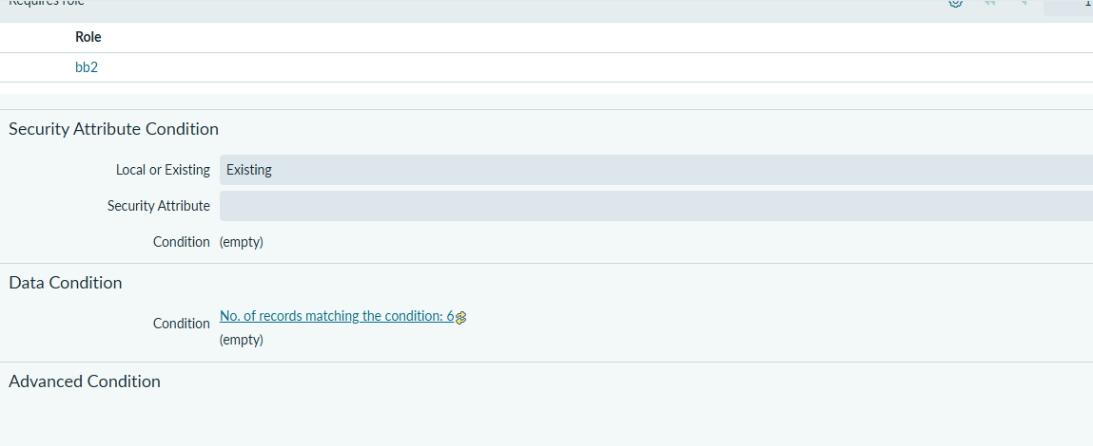
Figure 4. CREATE ACL details showing the bb2 role requirement.

12. CREATE ACL Verification

The lab verifies the Create ACL by using a user with the bb1 and bb2 roles and checking the presence of the New button. The expected behavior documented by the lab is that the user can view the applicable EEE records and has the ability to create a new record.

13. WRITE ACL

The WRITE ACL controls modification of existing records. It is configured as a record ACL with Operation = Write, Name = u_institution_details, and Active = true. The required role is bb3 and no data condition is specified.
- Type: record
- Operation: write
- Name: u_institution_details
- Active: true
- Required role: bb3
- Data condition: none
The documented verification uses a user with bb1, bb2, and bb3. This user is expected to view and edit the EEE branch records and retain the New button.

14. DELETE ACL

The DELETE ACL controls deletion of existing records. It is configured as a record ACL with Operation = Delete, Name = u_institution_details, and Active = true. The required role is bb4, with no data condition.
- Type: record
- Operation: delete
- Name: u_institution_details
- Active: true
- Required role: bb4
- Data condition: none
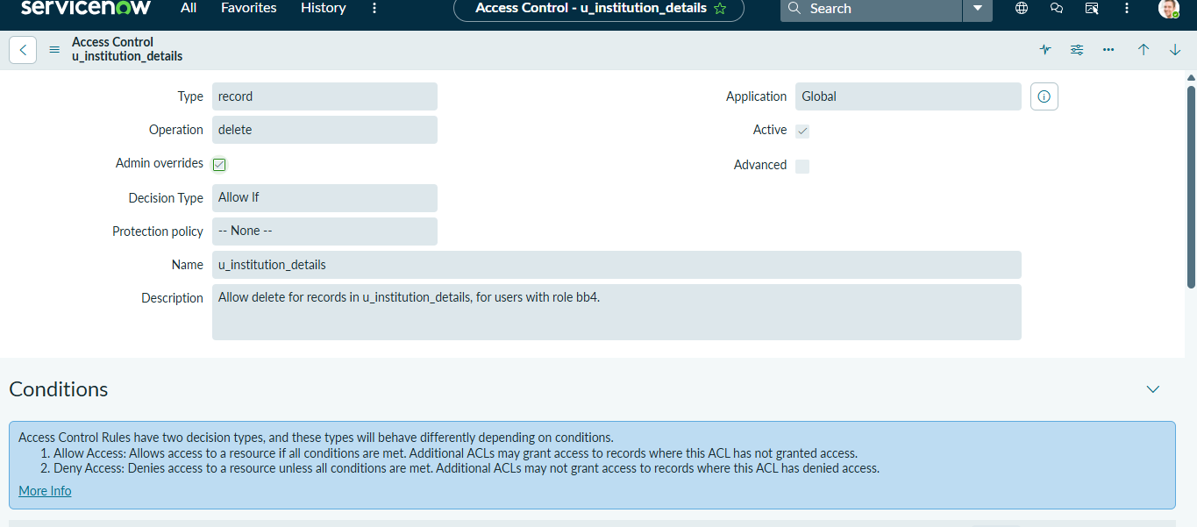
Figure 5. Delete operation ACL configuration for u_institution_details.
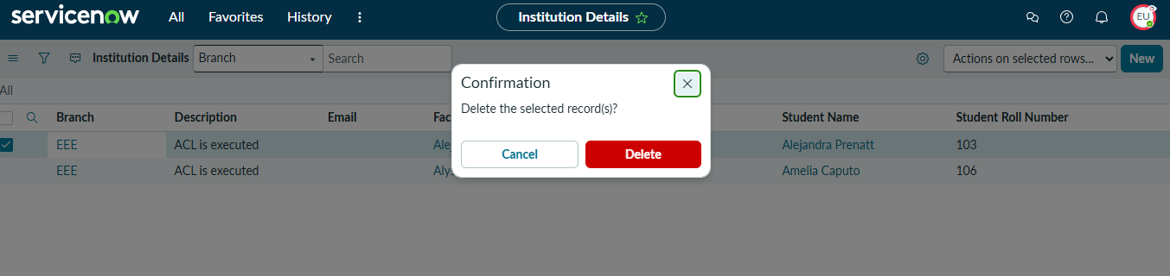
Figure 6. Delete confirmation shown when a record is selected for deletion.
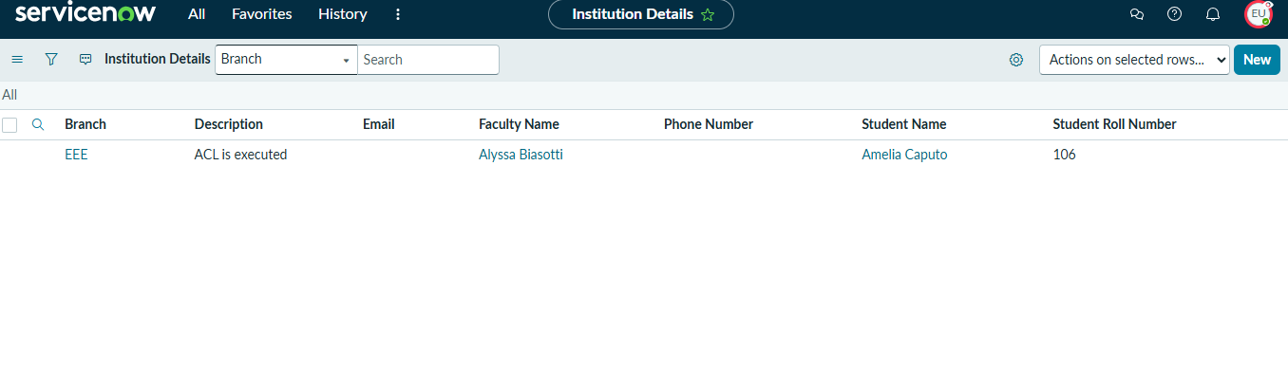
Figure 7. Institution Details list after a deletion operation.
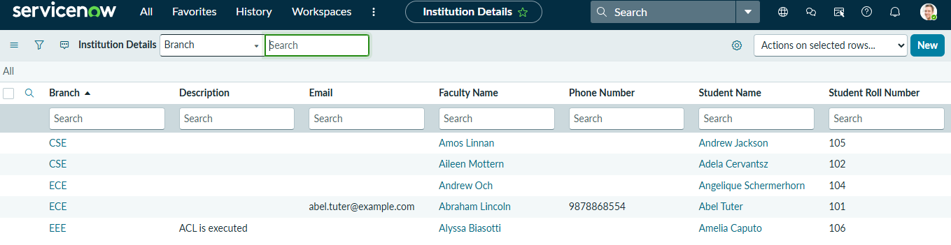
Figure 8. Institution Details records displayed after ACL-controlled deletion.

15. Testing and Verification

Testing is performed by impersonating users with different combinations of roles and checking the records and available operations. The purpose is to confirm that each ACL operation is independently controlled by its required role and that the READ scenario applies the EEE branch condition.
User / Role Combination | Expected Access | Operation Checked | Result to Verify
Admin | Full access | Read / Create / Write / Delete | All applicable records and operations available
bb1 | EEE records | Read | Only the permitted EEE records are visible
bb1 + bb2 | EEE records + create | Create | New button is available
bb1 + bb2 + bb3 | EEE records + create + edit | Write | Existing permitted records can be modified
bb1 + bb2 + bb3 + bb4 | EEE records + all operations | Delete | Permitted records can be deleted
User without required role | Restricted | Read | Protected records are not accessible

16. Security Workflow

The overall security workflow can be summarized as follows:
- User signs in to ServiceNow.
- ServiceNow identifies the user's roles.
- The requested operation is matched against the relevant ACL.
- For READ, the u_institution_details ACL uses the bb1 role and the Branch = EEE data condition.
- The ACL script explicitly permits administrators and users with bb1, and denies others.
- For CREATE, WRITE, and DELETE, the corresponding bb2, bb3, and bb4 ACLs control the operation.
- The resulting permissions determine whether the user can view, create, edit, or delete the record.

17. Results

The project demonstrates a layered record-security model. The READ configuration combines a role requirement with a Branch = EEE data condition, while the remaining CRUD operations are controlled through separate role-based ACLs. The supplied lab's final verification states that users with bb1, bb2, bb3, and bb4 can see, create, edit, and delete EEE branch records, while administrators retain full access.

18. Advantages

- Provides record-level security rather than relying only on application navigation restrictions.
- Separates permissions by operation, making Create, Write, and Delete controls explicit.
- Supports role-based access through custom roles.
- Allows record-field-based restrictions through ACL data conditions.
- Can protect sensitive records across forms, lists, and Service Portal interfaces.
- Can be tested safely using impersonation before deployment.

19. Conclusion

This ServiceNow micro project demonstrates how Access Control Lists can be used to implement fine-grained record security. A custom Institution Details table is protected through separate READ, CREATE, WRITE, and DELETE ACLs. The READ ACL combines the bb1 role with a Branch = EEE data condition and an ACL script that explicitly handles administrator and bb1 access. Additional roles—bb2, bb3, and bb4—control creation, modification, and deletion. The resulting configuration illustrates how ServiceNow can evaluate user roles, requested operations, and record conditions to protect data from unauthorized access or modification.
project conversation.

